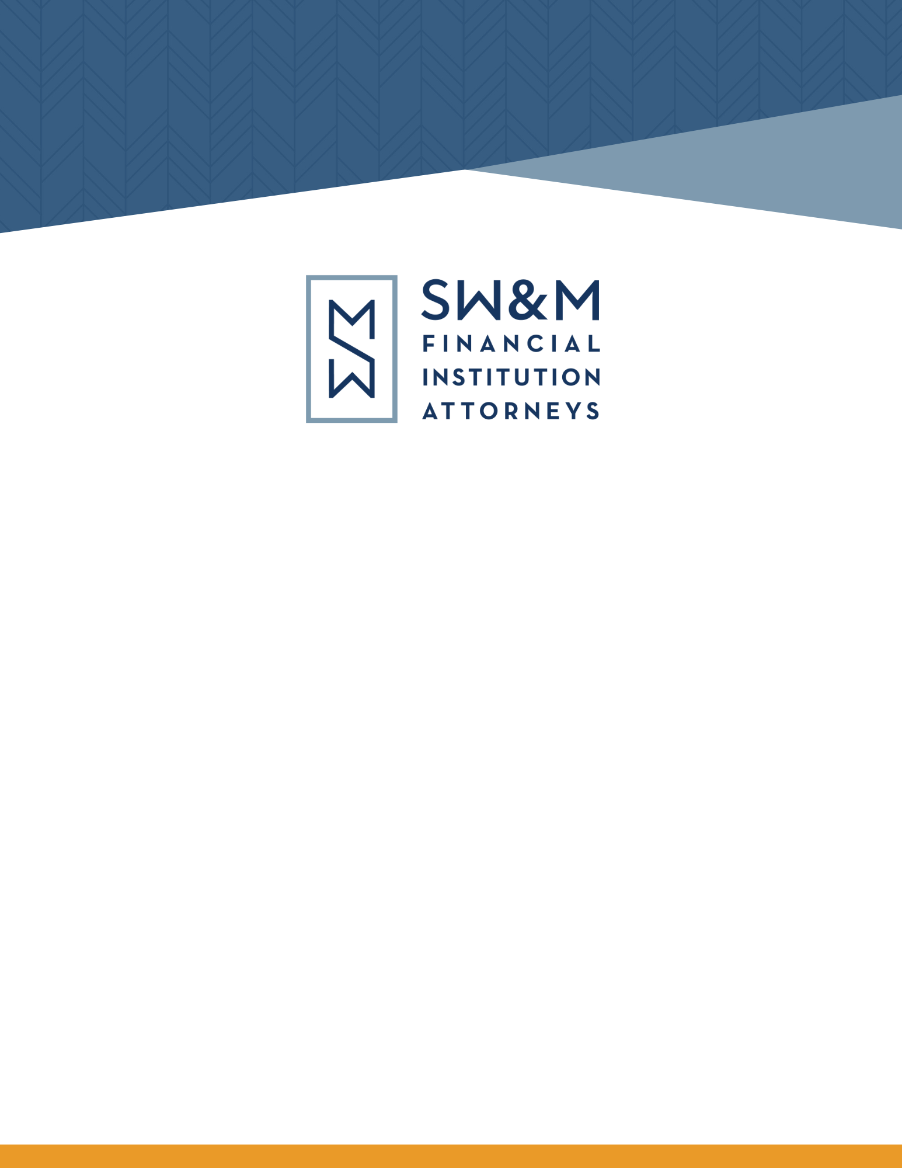

2025 Legal Update

SWMLLP.COM
DISCLAIMER
These materials were prepared by the attorneys of Styskal, Wiese & Melchione, LLP. Although this Year End Legal Update was prepared with care, it is not designed to be a complete or definitive analysis of the law in this area. This Year End Legal Update discusses legal developments in various states. Laws in other states may vary or are not addressed herein. Moreover, this Year End Legal Update was prepared with the understanding it reflects the authors’ perception of the state of the law as of this date. Furthermore, the information contained in this Year End Legal Update is not intended to constitute and should not be received as legal advice and does not in any way create an attorney-client relationship.
If you have any questions, or require further information on these materials, please do not hesitate to call our office at: (818) 241-0103.

SW&M 2025 YEAR END LEGAL UPDATE
TABLE OF CONTENTS

I. INTRODUCTION 7
II. ARTIFICIAL INTELLIGENCE 7
A. Executive Order: Ensuring a National Policy Framework for Artificial Intelligence 7
B. Colorado Update 8
C. CA AB 316 Artificial Intelligence: Defenses 9
D. CA AB 979: California Cybersecurity Integration Center 9
E. California AI & Employment Regulations 10
F. TX HB149: Texas Regulation of Use of Artificial Intelligence 11
III. HUMPHREY’S EXECUTOR: SEPARATION (OF POWERS) ANXIETY 13
A. Historical Background – Myers v. United States and Humphrey’s Executor 14
B. Lamb to the Slaughter? SCOTUS to Decide Whether Humphrey’s Executor Gets the Axe. 15
C. The Short- and Long-Term of Effects of Trump v. Slaughter and the Possible Demise of Humphrey’s Executor 16
IV. GENIUS ACT 18
V. THE CONTINUED WAR ON “JUNK” FEES 20
VI. ANTITRUST IMPACTS ON MERGERS & ACQUISITIONS 23
A. Federal Hart-Scott-Rodino Antitrust Notifications 23
B. States Enacting or Studying Uniform Antitrust Pre-Merger Notification Act 26
VII. MONEY TRANSMISSION 27
VIII. CONTRACTS & VENDOR MANAGEMENT 28
A. Notice & Cure Reminder 28
B. Vendor Management: New York’s New Guidance 29
IX. PRIVACY 29
A. CA SB446: Data Breach Notification Amendment 30
B. CA AB656: Social Media Account Deletion Requirements 30
C. CA SB361: Data Brokers 31
X. DIGITAL PROTECTIONS FOR MINORS 32
A. VA SB854: Minor Access Limitations on Social Media Platforms 32
B. VT SB 69: Age-Appropriate Design Code Act 32
XI. LENDING 33
A. “Zombie Mortgages” 34
1. CA AB 130 34
2. NH HB437 35
B. California Disaster-Related Legislation 36
1. CA AB238: Disaster Related Mortgage Forbearance 36
2. CA SB610: Mobile Home Disaster Assistance 38
C. Interest on Escrow Accounts & Similar Deposits 38
1. CA AB493: Hazard Insurance 38
2. AZ SB 1206: Adoption of Uniform Special Deposits Act 39
D. CA AB771: Fixture Filings 39
E. CA AB1521: Judiciary Omnibus 40
F. US HR2808: Homebuyers Privacy Protection Act 41
XII. COMMERCIAL LENDING – DISCLOSURES 41
XIII. ARBITRATION & ARBITRATION CLAUSES 43
A. Developments in Litigation 44
1. Ninth Circuit Smacks Down Efforts to Circumvent “Mass Arbitration” 44
2. The California Supreme Court Saves – But Sharply Limits – Provisions of the California Arbitration Act 45
B. CA SB82: Arbitration Agreements in Contracts for Consumer Goods and Services 47
XIV. EMPLOYMENT 48
A. The One Big Beautiful Bill’s 21% Excise Tax on Executive Compensation 48
B. CA AB692: Ban on Stay or Pay Agreement 49
C. CA SB464: Pay Data Reporting Expanded 51
D. Personnel Records 51
1. CA SB513 52
2. WA HB1308 52
E. Changes in Leave 54
1. CA SB590: Expanded Paid Family Leave Benefits Now Include “Designated Persons” 54
2. WA HB1875: Expanded Paid Sick Leave 54
3. WA HB1213: Expansion of Washington’s Paid Family and Medical Leave Program 55
F. Wage Scales & Benefits – Posting & Discrimination 57
1. CA SB642: Discrimination in Wage Scales & Benefits 57
2. WA SB5408: Amendments to the Equal Pay and Opportunities Act 58
G. CA SB 294: The Workplace Know Your Rights Act 59
H. “Non-Competes” in Employment Arrangements – Colorado 59
I. VT S 117: Updates to laws relating to wage and hour, unemployment compensation, and workers’ compensation 61
J. WA HB1747: Expansion of Washington’s Fair Chance Act 61
K. WA SB5101: Unpaid Leave and Safety Accommodations for Victims of Hate 62
L. WA SB5217: Expanding Pregnancy Accommodations 63
M. WA SB5501: Driver’s Licenses for Employment 64
N. State-Level WARN Act Developments 64
1. CA SB 617: WARN Notice 64
2. WA SB5525: Securing Timely Notification and Benefits for Laid-Off Employees Act, Washington’s mini-WARN 65
O. Procedural Enforcement Changes 66
1. CA SB 477: Updates to FEHA Enforcement Procedures 66
2. CA AB 1523: Court Ordered Mediation Threshold Raised to $75K 67
3. SB261: DLSE Enforcement of Wage Judgments 68
4. CO HB1001: Increased Wage Act Penalties and Enforcement 68
XV. TELEPHONE CONSUMER PROTECTION ACT DEVELOPMENTS 70
A. Supreme Court Weighs-In Through McKesson 70
B. VA SB 1339: Telephone Privacy Protection Act 71
XVI. ESCHEATMENT 72
A. CA SB822: Unclaimed Digital Financial Assets 72
B. CO HB 25-1224: Modifications to Colorado’s Revised Uniform Unclaimed Property Act 72
C. WA SB 5316: Modifications to Washington’s Revised Uniform Unclaimed Property Act 73
XVII. DECEDENT ACCOUNTS 73
A. AZ HB2116: Small Estate Administration 73
XVIII. NOTARIZATION 74
XIX. CHANGE TO STATE REGULATORY AUTHORITY 74
A. California DFPI Regulatory Authority 74
B. AZ HB 2054: Licensing and Insurance 75
C. AZ HB 2368: Auditor General Access to Financial Institution Records of State Agencies or Programs 75

